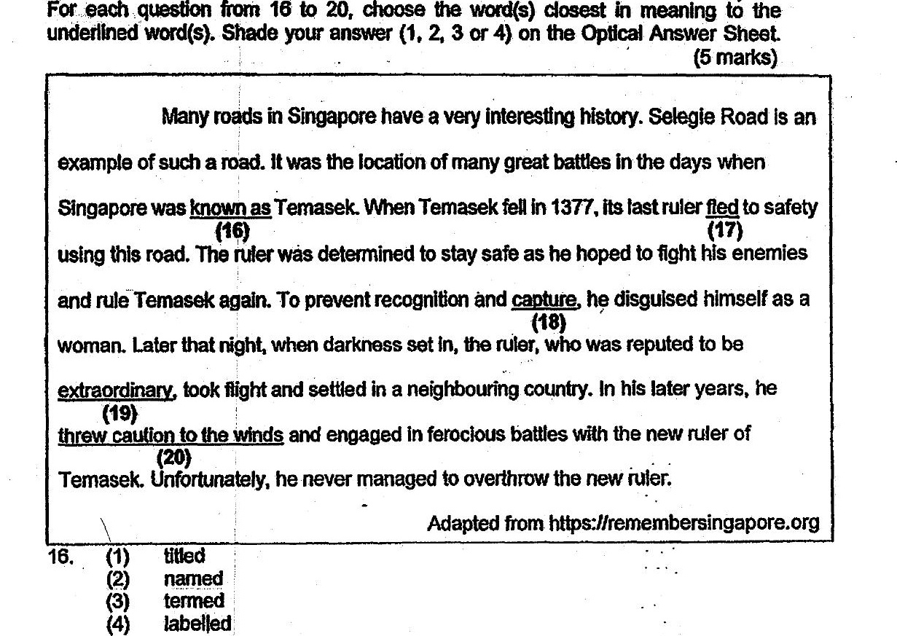

17. (1) sipped  
(2) expelled  
(3) escaped  
(4) retreated

18. (4) — artest  
(2) evasion  
(3) detention  
(4) harassment

19. (1) = brave  
(2) heroic  
(3) brilliant  
(4) remarkable

20. (4) was reckiess  
(2} made up his mind  
(3) became desperate  
(4) was at his wits’ end